**Increase Creativity Report**

**Add & Subtract**

Explain what you decided to add and subtract from your daily routine this week.

I decided to add journal writing and subtract screens in bed.

**Progress**

How many days have you already completed your additions and subtractions from your daily routine? Explain your experience so far.

I did both Monday and Tuesday, but I forgot to not have screens in bed on Wednesday (today).

**Four Activities**

You will need to choose and complete four creativity increasing activities from the list provided. You should spend at least 20 minutes on each of these activities. You will describe your experience with each and you will need to find a way to record and showcase some results of each activity.

**Activity #1**

**Black Out Poetry**

This activity was probably the easiest for me, because the content was there, I just had to make the lines through to create it. I had a hard time finding the articles to use. I realized after I started my family doesn’t have newspaper, or any sort of articles. I had to be creative with the original content, but I think I did fairly well, and I had a lot of fun!

**Activity #2**

**Free Association**

This was a really fun activity, and probably my favorite that I have done. I did it with my sister. The second time was probably the longest, and the most cohesive. The ones not recorded also flowed nicer, because we didn’t feel on the spot.

Free Association #1 (in comment).

Free Association #2 (in comment).

**Activity #3**

**Scribble Game**

I had a lot of fun with this one. It is probably the worst artistic wise, but it was fun. I have done this activity before, we would do it a lot on my mission to pass the time. I only got two pictures at the beginning, but I played it with my younger sisters, and they gave some challenging scribbles.

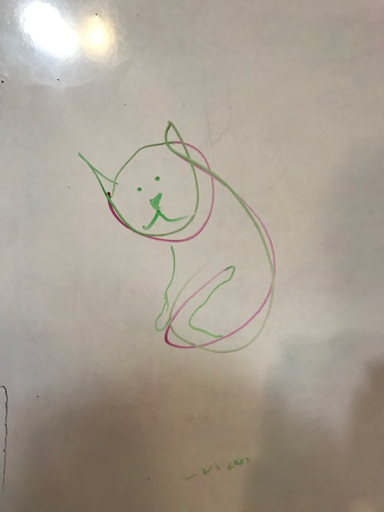

**Activity #4**

**Mind Map**

I asked my siblings to help with the Mind Map Activity. Here are the two that I remembered to take pictures of before they were erased. It was so much fun. The longer we did it the more answers, and the easier it was

**Submission**

Save this completed document as a PDF (File -> Save As - > File Format: PDF)

Submit the PDF in I-Learn